Sri Sathya Sai Vidya Mandir
Annual Report- 2018-19
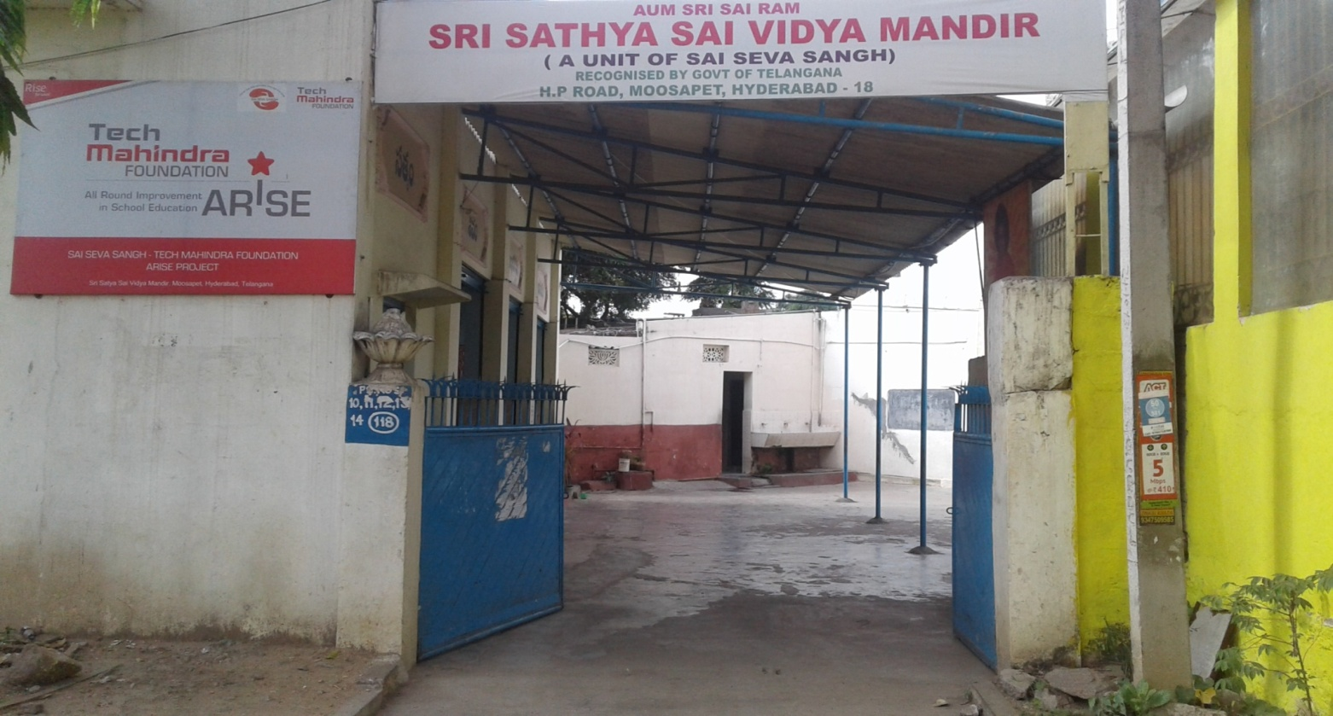

Introduction
Sai Seva Sangh is a non-for-profit organization working with children, women from low-income and underprivileged communities in the field of education. It is a registered society under Societies Act and holds a valid exemption certificate under section 80 G of the Income Tax Act.
The groundwork for what is SAI SEVA SANGH today was laid in August 1988, when a few like-minded people came together for a common cause to educate underprivileged children in their neighborhood, providing free shelter to old and destitute women, and support system for a rural Special School for differently abled. All the services rendered under various units of Sai Seva Sangh are totally free of cost.
Currently, the School and Orphanage is being supported by Philanthropists and group of individual patrons supporting the cause by way of contributions in kind & cash.
Volunteerism support is another major support in the form of teachers (Academic & Non-Academic). The overall running costs of these units of Sai Seva Sangh is Rs.110 lakhs per annum. All systems are in place for each of the Unit of SaiSevaSangh. All statutory requirements are met timely, and audited accounts for the organization are available which are being filed for annual statutory obligation as per rules. Periodical reviews and evaluations are done through internal members appraisals periodically.

School Background
Recognized by Board of Secondary Education, Government of Telangana – Grade I to X
Our Vision

- To empower girl children through integral education focussed on academic and non-academic learning, nurturing confidence, self-esteem and self-awareness and moulding them as ideal citizens devoted to the service of society.
Our Mission

- To enable a brighter future for girl children from low-income communities by providing them with the desired knowledge, skills, values and support to achieve their true potential.
- To ensure that every child of school going age is gaining a strong and holistic educational foundation to become socially responsible, compassionate and confident citizen of tomorrow.

The VidyaMandir School aims to provide a solid and holistic educational foundation to children from slums and low-income communities completely free of cost. It aims to bridge the learning gaps and ensure that the children pursue their schooling addressing drop out from education curriculum. Teaching methods focus not only on academic education but also on non-academic learning to mould and nurture confidence, self-esteem and self-awareness. Upholding the principle of holistic learning, the curriculum is implemented through lecture, demonstrations and experiments as well as experiential learning through celebrations, events, field trips and workshops.

Assessments are conducted on a regular basis with the purpose of adapting the curriculum to meet the students’ needs. Student performance analysis enables us to identify students with remedial needs; students with learning disabilities and students who needs teacher’s stern eye and create solutions within the environment of the School that each student achieves their true potential. The Vidya Mandir school is an effort towards instilling the faith, belief and culture of “empowerment through education” in the minds of children from low income communities to ensure that they pursue the path of knowledge, skills and values needed in order to break the restraints of illiteracy.

TMF Intervention
In the year 2018, it was a great opportunity and opening for school when Tech Mahindra Foundation (TMF) came forward to support the school towards sustainability and signed an MOU. Tech Mahindra Foundation’s ARISE (All round improvement in school education) for Sri Satya Sai Vidya Mandir is undertaken to improve the standard and quality of education provided in the school at Moosapet. The following objectives were agreed to achieve the desired outcomes. CfBT education services, training partner of TMF helped the school with designing, implementation of various measuring tools and capacity building of teachers.

It outlines the findings from self–assessment of students through baseline and End line studies that were conducted which reflect the impact and improved learning of students during the past one year.
Project objectives

- To employ specific subject wise professional teachers for improving the standard of teaching and learning that will result in students academic performance by at least 50%.
- To improve the communication skills in English (particularly speaking and writing skills) of all students by at least 50% thereby contributing to holistic development of the child.
- To provide a wide range of extra-curricular activities to foster students ‘all-round development, nurturing and developing their character and potential.
- To develop in students a sense of awareness with respect to their community and encourage to begin solving the problems thus instilling leadership skills.

Tech Mahindra intervention helped the school with the financial stability and the academic help throughout the year which acted as a catalyst towards achieving the drafted objectives.
2018-19

To begin with, the school with support from CfBT education services recruited total 14 full time teachers. The recruitment lead to the following positive outcomes:

- Stable teacher manpower to the school.
- Better student teacher ratio.
- Structured classroom teaching.
- After school academic support for students throughout.
- Improvement in student attendance.

This year began with school reopening on 1st June. The total strength of the school for the academic year 2018-19 was 287. The year also witnessed a major change with conversion into all girls campus.

The teacher’s induction was conducted on 24th May where the school’s vision was drafted with everybody’s input. The teachers drafted their classroom vision and brainstormed on steps to take to achieve the same.

Baseline assessments

INTRODUCTION

This Baseline study was undertaken to establish a starting point against which CfBT Education Services will measure the impact on learning for ARISE activities in Sri Sathya Sai Vidhya Mandhir High School. The study gathered and assessed quantitative data from the students of grades 1 to 9.
The main objective of the study was to conduct a baseline that will enable CfBT to assess the projects’ Outcomes. A second objective was to design appropriate capacity building inputs to promote better teaching practices in the school.
The graph below depicts the average outcomes of baseline assessment.

Overview of students’ academic achievement

Of the sample size of around 250 students,
- The performance scores were slightly higher in English language skills as compared to Math and Science.
- EVS/Science recorded lowest performance scores out of all three core subjects studied as there were considerable non-attempts.
- On an average, grade 3 & 8 students have performed better than all other grades in prescribed outcomes though their consolidated percentages are in the range 37%-38%.
- Math came second when consolidated percentages are compared; with grades 1 & 2 scoring the most and grades 5 & 7 scoring the least.
- Science which included EVS for grades 3-5 recorded lower scores compared to rest; with grade 7 scoring the least and grade 4 scoring the most.

Learning Issues
- Most students lacked the ability to read and understand the questions and attempt a right/wrong answer. Grades 1-3 students required some assistance in reading out the questions by examiner to make sense and attempt.
- In case of oral assessment, students fared well on basic level activities/questions but higher order activities which required thinking, application, analysis and evaluation could not be well attempted.
- Students fared well/attempted questions which are at ‘Remembering’ and ‘Understanding’ levels of Bloom’s Taxonomy.

Based on the above findings and in order to make sure excellent holistic education was provided to children the following activities were conducted throughout the year.
Activities around the year

Project Literacy:

What?

English is being taught in classroom as Reading Comprehension (RC), Reading Fluency (RF) and Writing as per grade level with good amount of time dedicated throughout the week for all the three skills. Objective based teaching of English helped the students better their comprehending skills.
Library has been setup at different places around the school to make sure kids are always surrounded by books and have the freedom to pick up any book of their choice and read. With accessibility to books unlike previous years kids have been enjoying their reading time and are looking forward to their library hours. Library books have also become a part of their English curriculum.
Story wheels have been introduced in secondary classrooms for comprehending the stories in their textbook and make a summary in the form of wheels thus helping them in scoring better in their government exams.
Progress:

- Improve in the overall communication skills in students.
- 20% children in the class showing improvement in their reading skills.
- 10% students in primary grades able to comprehend simple stories.
- 30% students in higher grades able to comprehend rigorous text.
- 30% of students in grade 1 & 2 able to recognize phonetics and sounds.

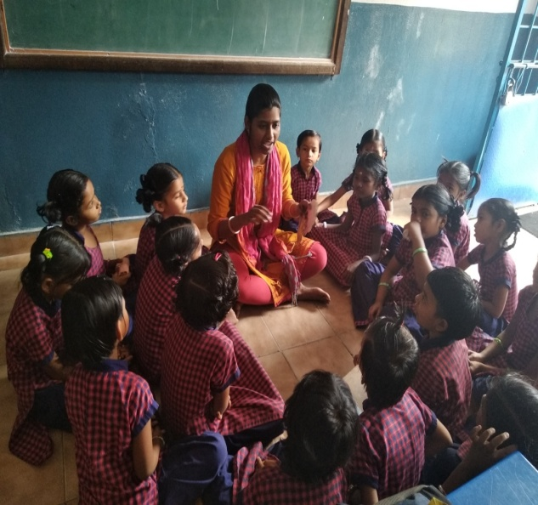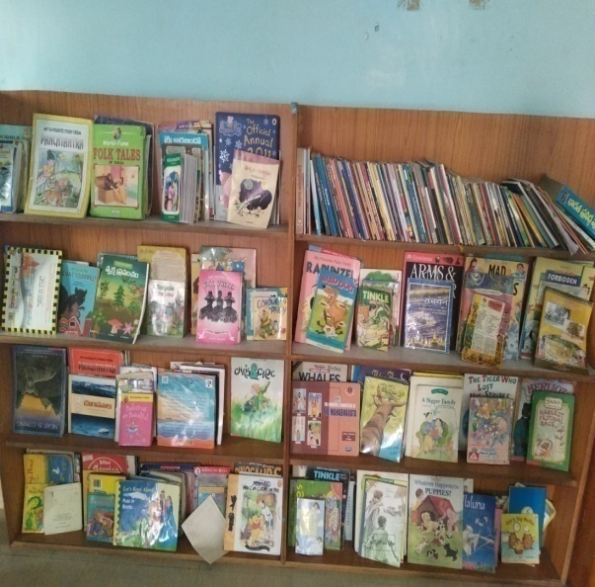

Capacity building of teachers

What?

- 12 sessions of training on general pedagogy and 4 sessions on ICT equipments conducted throughout the year with support from CfBT education services.
- Lesson planning with grade and content specific activities.
- Drafting of objectives based on learning outcomes focusing on different levels of Blooms Taxonomy.
- All the teachers trained on using PowerPoint to making PPT, using excel to record data and analyze, use word to make assessments and worksheets
- Drafting short term goals focusing on one learning outcome per timeframe and striving to achieve the same.
- Three periods in a week dedicated to digital teaching for 2nd grade.
- Monthly classroom observations with debrief conducted for all the teachers.
- Quarterly external review conducted by CFbt Education services and documented.
Progress:

- Focus shifting to learner centered classroom from teacher centered classrooms.
- Delivery of the lessons focusing both on content and skill being imparted.
- Better engaged classrooms with joyful learning.
- 6 classrooms showed an improvement of 3% on average in FA 2 exams compared to FA1
- 20% of children proactively asking questions in the classroom.
- Improvement in reading skills of grade 1 and 2.
- All the SA2 question papers for grade 1 to 5 prepared using Ms Word.
- Maths teachers prepared worksheets for grade 1 to 5 as a part of revision.
- All the teachers tracked their FA and SA marks in excel, analyzed the same using graphs.

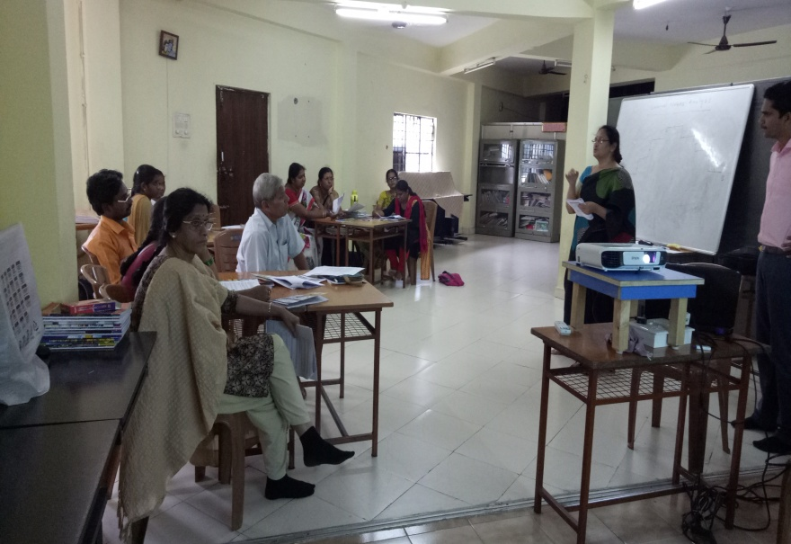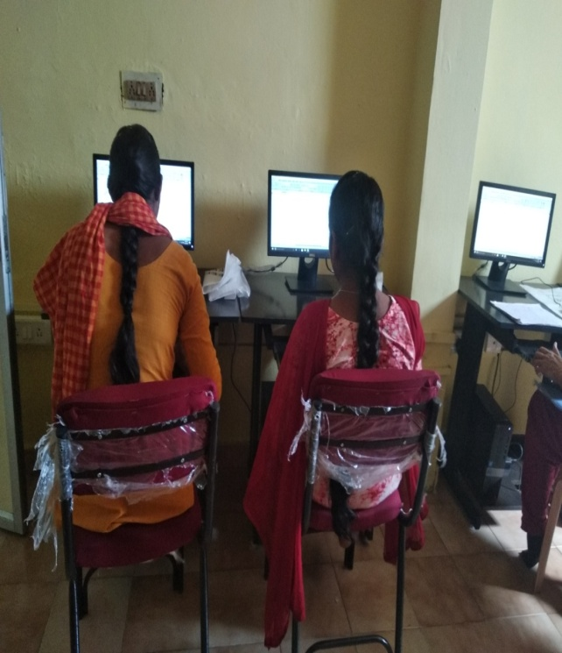
Access and Exposure

What/ How?
- Student led assembly.
- Student led celebrations of various events in the school.
- Practical exposure of science concepts through Mobile Science Lab.
- Learning science through doing.
- Participation in national level Olympiads.
Progress
- 60% of students in each class taking initiative for the various performance during the assembly ( drama, speech, etc)
- Student led celebrations of teacher’s day and Independence Day.
- 6students participated in external karate competitions at district level and won 3 gold and 1 silver medals
- 10 students participated in 10th anniversary celebrations of Ramdev hospital.
- Total of 100 students across grade 6 to 10 participated in the cultural and sports competitions conducted among all the Satya Sai schools across south India. School won 3 gold medals, 2 silver, medals and 5 bronze medals in various games and sports competitions conducted among. The march past team won the 2nd prize and the Students participating in martial arts and karate display won 3rd prize.

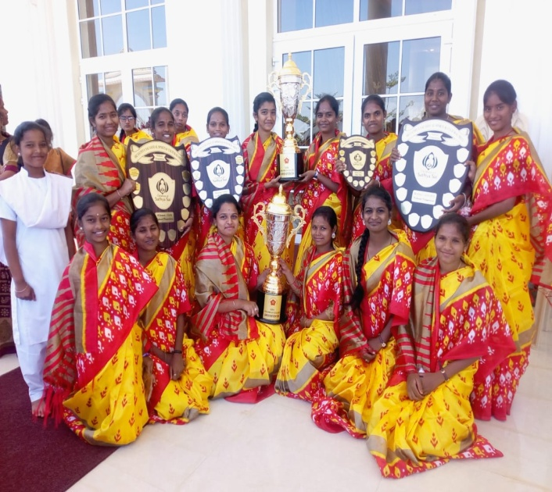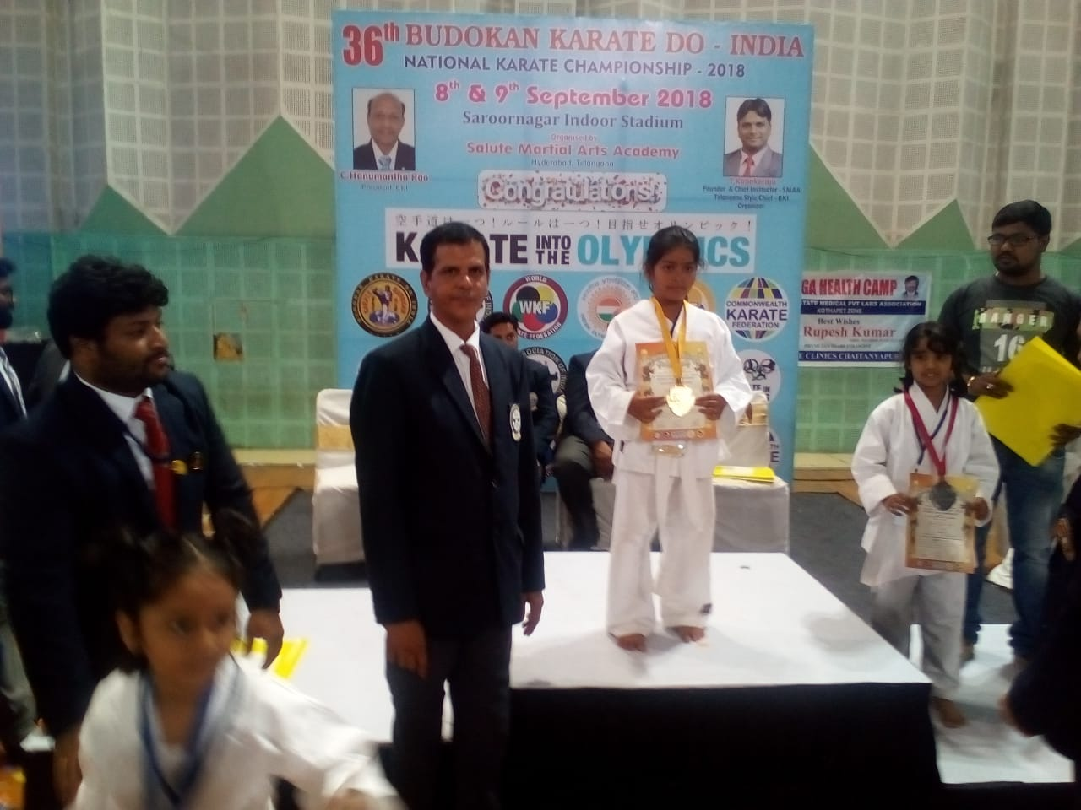

External Exposure

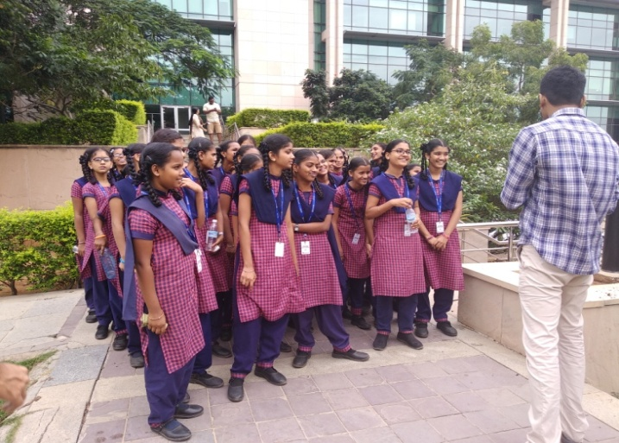
Students from grade 6th to 10th were taken to Do science park and were given real life practical experience to various physics concepts. The students thoroughly enjoyed learning the various science concepts through doing. They were then taken to botanical garden where they explored the various types of flora and fauna.

Students of grade 8th, 9th and 10th visited Microsoft office as a part of their exposure visit. The students walked around the campus and were taken through the various operational units and the work culture in the organization. Students also interacted with the employees and were left motivated.

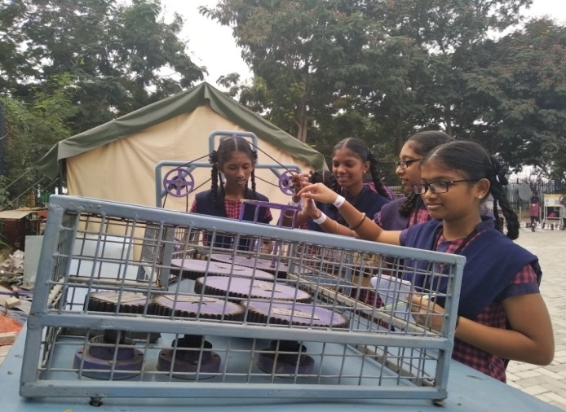
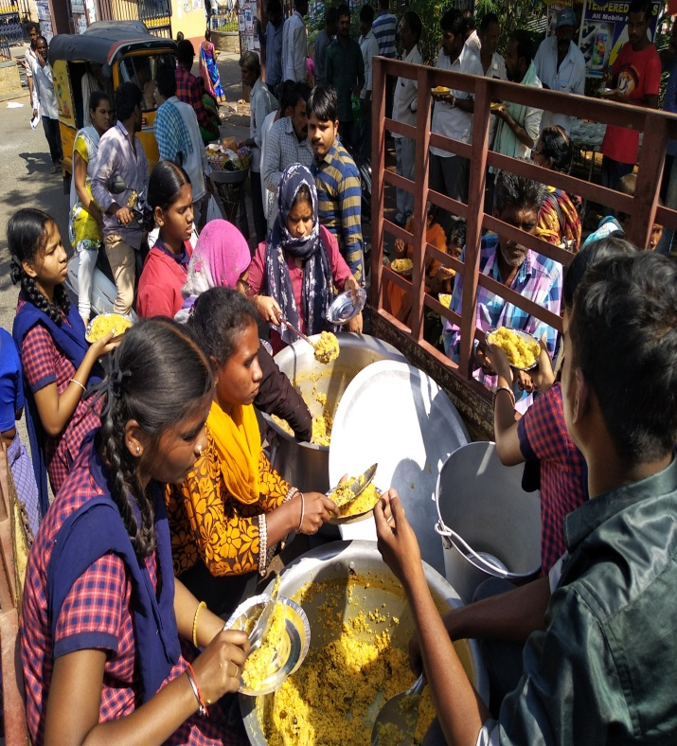
As a part of community service and to instill the values of empathy, giving and service towards society, students from various grades organized poor feeding. They visited various hospitals across the city and distributed cooked food packets. The students were left motivated and with a sense of gratitude at the end of the event.
Endline assessments
Introduction
This End line study was undertaken to establish the analysis against which CfBT Education Services will measure the impact and difference between baseline and end line on learning for ARISE activities in Sri Sathya Sai Vidhya Mandir.

The main objective of the study was to conduct end line assessment that will enable CfBT to assess the projects’ Outcomes in baseline and do comparative analysis of baseline and end line assessments

Overview of students’ academic achievement

Of the sample size of around 250 students on an average:
- students have performed well in English with an average of 49.02%
- Second is EVS with average of 40.78%,
- Third is Math with an average of 33.18% and
- The fourth is Science with a percentage of 29.47%
Overall comparative subject wise

English comparative all grades

Math comparative all grades

EVS comparative grade 3-5

Science comparative grades 6 – 9

SUBJECT COMPARISION

TOTAL AVERAGE ENGLISH, MATH, EVS & SCIENCE

School Assessments

The school has been conducting assessments as prescribed by government. The assessments were designed by the teachers for primary grades and the secondary grades students were assessed on the papers designed by the government of Telangana.
The following graph depicts the average growth in the each subject compared to the previous academic year.
Average subject wise SA2 marks (Grade 1 to grade 5)

Average subject wise SA2 marks (Grade 6th to 9th)

The school performed well in the SSC 10th board exams with a pass percentage of 100. All the 21 appeared students passed with highest score of 9.2. The graph depicts the number of students with the GPA scores.

Comparative scores of grade 10 SSC.

Comparative FA scores of grade 1 to 5 for the year 2018-19

Comparative FA scores of grade 6 to 10 for the year 2018-19

TMF intervention has played an important role in improvement of academic standards in the school from past 1 year. With the improved results and newer objectives we are working towards achieving more in the new academic year and move closer to our vision.

