Annual Report 2019-2020

The academic year began with school reopening on 12th June 2019 with a total strength of 302 across grades 1st to 10th. This year has been special as the school became functional into a fully girls’ campus thus focusing on our vision to provide quality value education to the girl child.

In pursuit of reaching our vision, the school framed the following objectives for the current academic year:
- To develop in students a sense of awareness with respect to their community and encourage to begin solve problems thus instilling leadership skills.
- To develop parental investment in their child’s education leading to reduction in absenteeism.
- 70% of the students in each classroom to reach their literacy grade level.
- 5% average increase across classrooms per quarter in maths scores.
- Project literacy to become completely student owned.
- To setup fully functional science lab with the help of science teachers.
Baseline Assessments
This Baseline study was undertaken to establish a starting point against which CFBT Education Services will measure the impact on learning for ARISE activities in Sri Sathya Sai Vidhya Mandhir High School. The study gathered and assessed quantitative data from the students of grades 1 to 9.
The main objective of the study was to conduct a baseline that will enable CFBT to assess the projects’ Outcomes. A second objective was to design appropriate capacity building inputs to promote better teaching practices in the school. The endline assessments of year 2018 were taken as baseline for year 2019.
The following graph depicts the average outcomes of baseline assessment.

Overview of baseline performance:
- The performance scores were slightly higher in English language as compared to other subjects.
- Math and Science recorded lowest performance scores out of all three core subjects studied as there were considerable non-attempts.
- EVS came second when consolidated percentages are compared.

Analysis:
Based on the performance in the baseline assessment, an analysis was made by CFBT in order to train teachers and putforth more emphasis on the subjects where the performance needs to be improved. This analysis was taken as input for the planning of academics.

Activities around the year
1)Teacher Professional Development
As teachers are an integral and most important part in the students development, training needs were analysed for the year in consultation with CFBT (Training Partner of Tech Mahindra Foundation) in the month of May 2019. A 12 day training was given to the teachers.
The training covered the following topics:
- SCERT Outcomes
- Review of Lesson Plans
- Differential Learning
- Assessment Methods
- Lesson Observation Tool
- Reflective practices
- Study Skills ( Home work plan)
All the teachers were trained on the above topics and were mentored to implement the same in their classrooms. The training also focussed on topics of general pedagogy that would benefit the teachers in classroom management.

LIFE (Learning integration of education services) was inducted in the school for grade 1 and 2. Total 5 teachers were taken through two hours training session for two days where they were taken through the module and the organizational culture. All the five teachers were given a detailed description of the whole program. After two weeks of preparation time, the lesson plans were shared with the teachers for implementation in the classrooms.
The teachers found this to be very effective and user friendly. The students are thoroughly enjoying their learning experience. The program focuses on integrating the academics with values and providing behavioural and emotional support to the students.

2)Initiative & Exposure
- Student led assembly.
- Student led celebrations of various events like international yoga day, Guru Poornima, Independence Day, Teacher’s Day, Bathukamma festival, in the school.
- Practical exposure of science concepts through Mobile Science Lab.
- Learning science through doing.

Student Enriching Program
Meridian School Visit: Meridian International school, Madhapur kick started a student enriching program for students of grade 4th and 5th. Students are taken to the school on every Wednesday and Friday. This month they learnt music, spoken English and Dramatics along with the students of Meridian School. This ongoing programme will help the students not only develop various skills but also the interaction with their peers will improve their confidence.

Accenture visit: Students of grade 7th, 8th and 9th were taken on a trip to Accenture on 18th October to attend an event organized for the students. The students were taken through different activities and games organized by the organization. Students also participated in cultural events. 10 girls performed classical dance and two groups participated in singing competitions.
The students were presented with a memento and certificate as a token of appreciation.
The opportunity provided students a good exposure and motivation. The students visit to the organization and participation in the cultural events boosted their confidence. It was a great movement of self reflection and motivation for students as they were getting appreciation, acknowledgments and applauds from everyone.
Yoga and Meditation Workshop: A workshop was conducted on meditation and yoga for the students of grade 4th -6th from 16/09/2019 to 18/09/2019. The workshop was conducted by a trainer from Art of living. It focused on teaching students the benefits of meditation to calm their mind. Students were also taught yoga asanas to make them physically active and mentally alert. Students were rejuvenated after the session.
Vedam Workshop: Vedam workshop was conducted for the students of grade 5th -9th on 21st and 22nd September, also on 14th and 15th march 2020 in the school premises. The workshop included learning of Ganapathi and Saraswathi Prarthana, Medhasuktams and Rudrams.
Motivational Sessions – 1) Positive thinking: On account of giving day, LIFE( Learning integration of education services ) conducted a session on 15th July on positive living. Shri Amarnath, CEO of LIFE took a motivational session for 44 students of grade 9th and 10th. The session emphasized on understanding ourselves as a person and how we could develop positive reflective practices for our overall development. The session was interactive with participation from all the students. The students left with a feeling of self-knowledge and lots of positive takeaways.

2) Value Education: A motivation session was conducted by Mrs. Radhika Sridhar, counsellor and a member of Sai Seva Sangh for the students of grade 8th and 9th on 9th August. The session focussed on:
1. to understand the innate potential
2. to explore themselves and effective utilisation of the same
3. to understand the Universal Laws and apply in their day to day life
4. the power of thoughts and its application
These sessions help to boost their confidence and self-esteem to perform better as a student. This orientation helped the students to look at their studies with a different perspective.
3)Gratitue: Most teachers do not receive the admiration and respect that they deserve. Teachers work extremely hard, dedicating their lives to educating youngsters. They want to make a difference in the lives of these young students, who will grow up and make a significant difference in the world. On account of gratitude day, Sri Kota Shiva Kumar garu, who is a spiritual coordinator of Sathya Sai Organization of Hyderabad, shares the importance of gratitude towards guru and in life to the students of 8th to 10th grades. He also explained the need of gratitude in one’s life. Students got to learn very much out of the session and lot of takeaways.
Medical Camp: Medical camp was conducted in the school premises for all the students from grade 1 to 10 by Ramdev Rao hospital. All the students had general medical checkup that included eye checkups.
Blood groups and hemoglobin levels of all the students were checked and recorded. Three students underwent surgery for cleft lip free of cost.

Sports Meet: The Annual Sports and Cultural Meet is one of the most special events in the calendar of the Sri Sathya Sai Institutions. With months of practice and hard work having gone into the preparing for this unique event, every year, 15th January marks the D-Day when the efforts of all the students and staff comes to fruition with a magnificent display of a vast array of sports in an effort to bring a smile to the face of their beloved Mother Sai.
Sri Sathya Vidya Mandir took part in the sports meet, who displayed their skills in the Shotokan Martial Arts. These young girls presented a range of skills ranging from karate to splendid displays of strength with weight lifting, tile breaking and pyramid formations among other things. Also performed dance ballet on “Nava Durga”, participated in the march past along with 26 schools.
Karate Competition: Karate Competition was held at YMCA Narayanaguda. 25 students from our school participated and bagged 12 gold, 8 silver and 5 bronze medals.
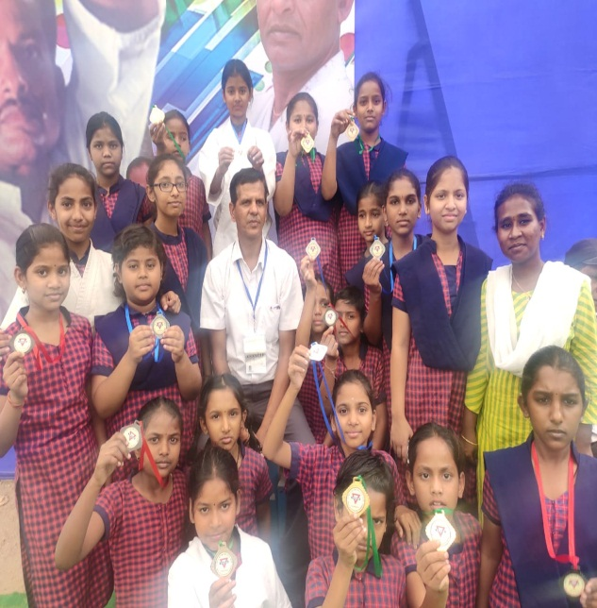 | 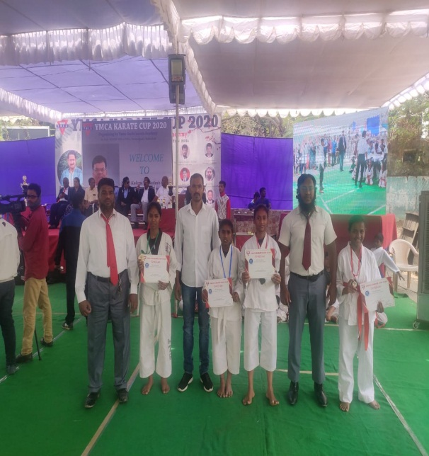

3)School Events
School celebrated many events which were led by students
- International yoga day
- Guru Poornima day
- Independence day
- Teacher’s day
- Bathukamma celebrations
- Gratitude day
- Republic day
- Endline Assessments
This End line study was undertaken to establish the analysis against which CfBT Education Services will measure the impact and difference between baseline and end line on learning for ARISE activities in Sri Sathya Sai Vidhya Mandir.

Endline assessments of all grades average score is depicted in the below graph.

Comparision of baseline and endline assessments average score

School Assessments
The school has been conducting assessments as prescribed by government. The assessments were designed by the teachers for primary grades and the secondary grades students were assessed on the papers designed by the government of Telangana.

The following graphs depicts the formative and summative assessments of all grades.

Tech Mahindra Foundation has played an important role in achieving our mission and focusing on our school vision. With the improved academic standards, results and newer objectives we are working towards achieving more in the coming academic year.

