SAI SEVA SANGH QUARTERLY REPORT OCT - DEC 2020

This year began with virtual learning due to unexpected pandemic. It has been quite challenging for all of us but Sai Seva Sangh is making every effort to bring the positive environment with the support of many organizations and individuals.
The total strength of the school from 2nd grade to 10th grade for the academic year 2020-21 is 260.
Highlights:
- Online Sessions: Online sessions are in progress from grade 2 to grade 10.
- Staff meetings: Regular staff meetings were conducted bi-weekly to discuss the challenges.
- Training: Skill development training like Time management, effective communication, google forms taken by teachers provided by TMF.
- Online training session on Child Safety provided by TMF which was held on 18th November
- Training on life skills for the teachers provided by LIFE.
- Along with academics, regular music, dance, karate and yoga classes are ongoing.
- Virtual classes on Vedam and Bhagavad gita are being conducted and ongoing.

October is the month of Dusherra. Celebrated festival with our children and elderly at home. Performed homam and puja, symbolizing triumph of good over evil. Children understood how important it is to help others and to do good. | 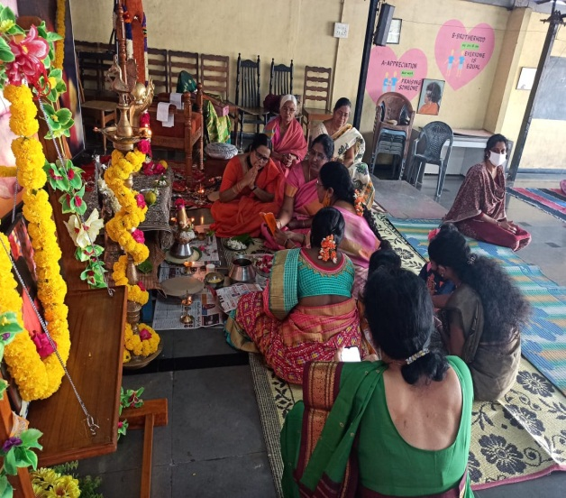

November month marks Swami’s birthday. Celebrated divine birthday with sankeerthanas, puja at home. We offered our gratitude to our beloved Swami at his lotus feet with NavaDurga dance ballet performance held at Muddenhalli. | 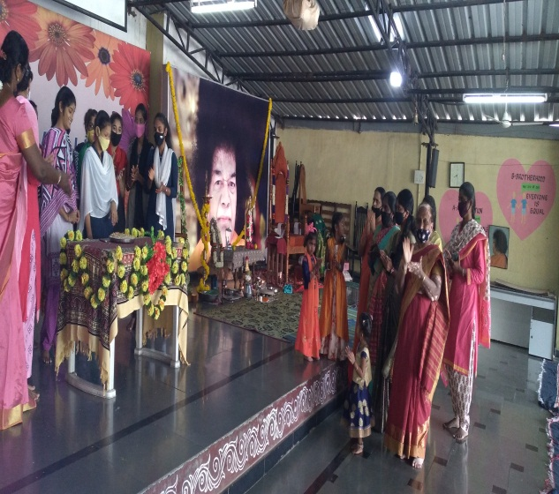
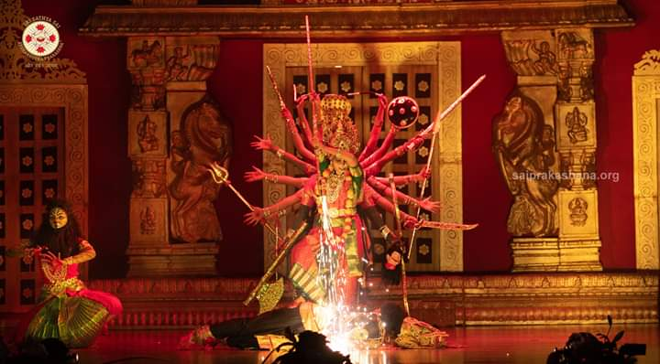 | 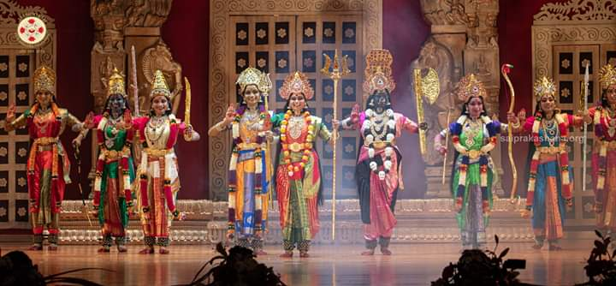
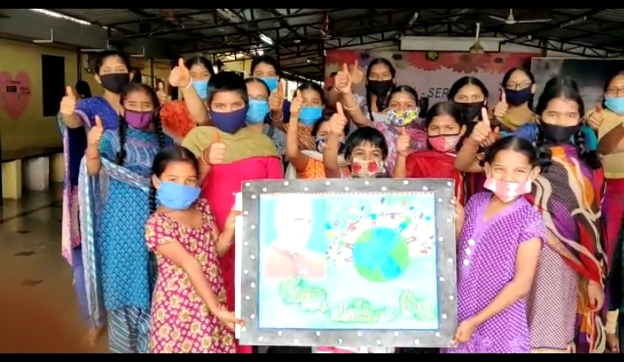 | This November month reminds us of children’s day. Our inmates have spent the day playing virtual games conducted by Microsoft. It was so generous of them that they have sent gifts to children at home.

Management meeting was held in the month of November and the keys points were discussed :
- As how to raise funds for higher education for inmates.
- About construction of dormitory and renovation of kitchen and store.
- Installation of solar panel to reduce the power bill.
- Discussed about reopening of school.
Also, there was a government inspection of orphanage and old age home.

In December month, meridian school conducted virtual Karyashala program. We also celebrated kisaan diwas, Christmas and new year. | 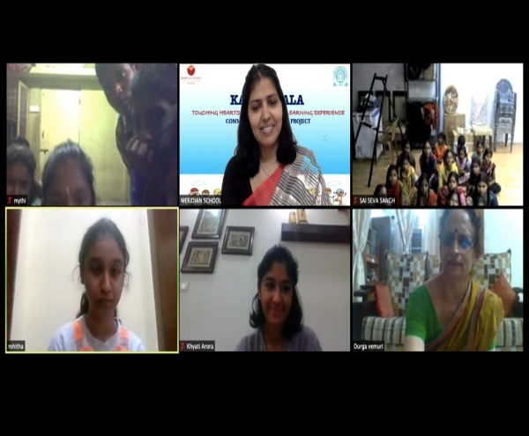
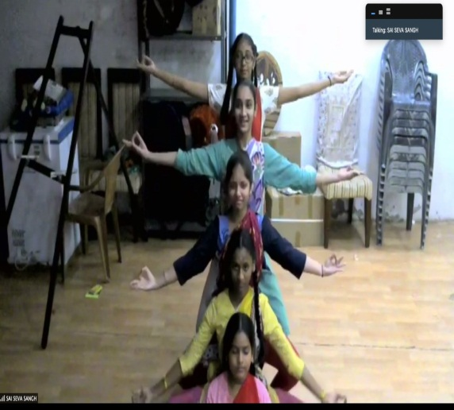 | Karyashala event included puppet show, fun with science experiments, nrithyashala and talent hunt, where our children showcased karate, dance, singing art forms. It was a 4 day event with fun filled activities.

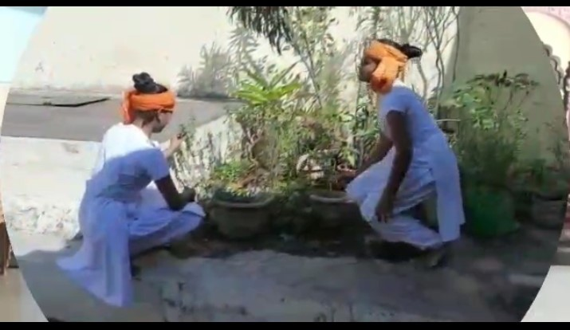 | Kisaan diwas was celebrated on December 23rd. A small skit was played by students of 9th and 10th graders. It was explained how important a farmer is to the society and country, how crop is cultivated and food gets to us. There is no existence without farmer.
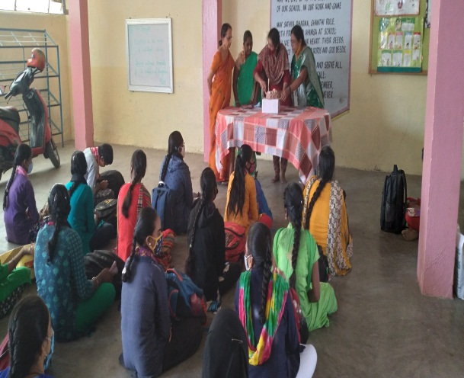 | 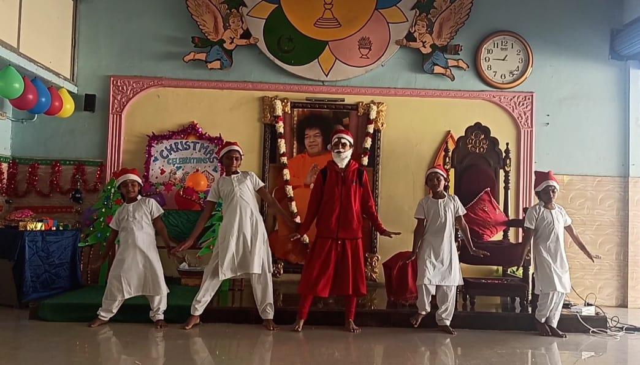

Every kid gets excited about Santa, Christmas tree and Christmas celebrations. They always cherish singing carols, dancing to those tunes. Celebrated welcoming New Year with new resolutions. The whole world faced challenges in year 2020, but still it taught us to be united, to support each other, to never let down however much big the challenge is. With this spirit, we will move forward with new hopes.
Parents Meet:
Management conducted meeting with parents about reopening of school for higher grades. They readily accepted and signed consent letters.

